**LoRaWAN DEVELOPMENT BOARD**

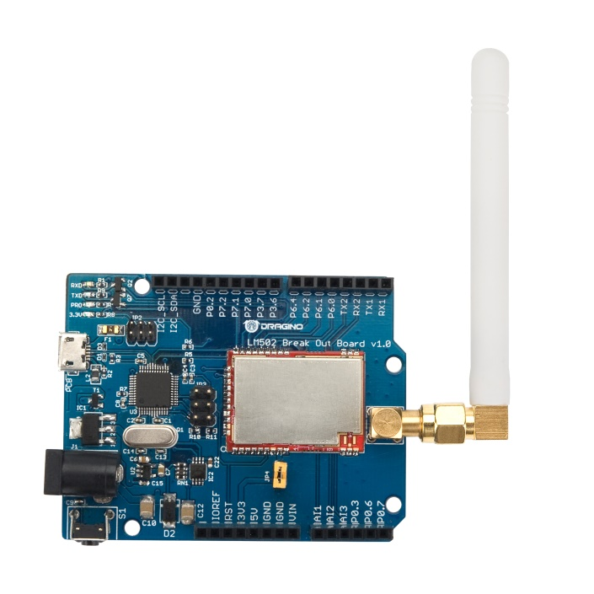 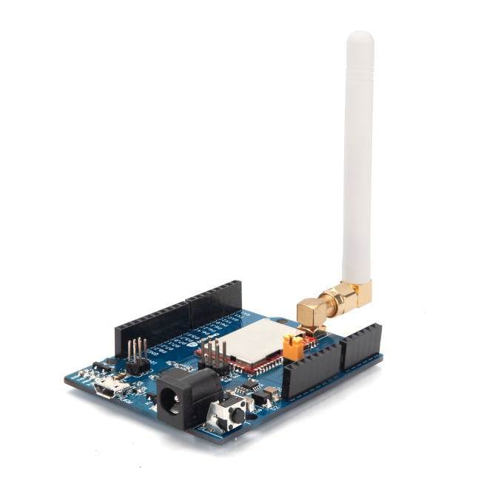

**Description**

The Dragino LT series I/O Modules are Long Range LoRa I/O Controller. It contains different I/O Interfaces such as: analog current Input, analog voltage input, relay output, digital input and digital output etc. The LT I/O Modules are designed to simplify the installation of I/O monitoring.

The LT I/O Controllers allows user to send data and reach extremely long ranges. It provides ultra-long range spread spectrum communication and high interference immunity whilst minimizing current consumption. It targets professional wireless sensor network applications such as irrigation systems, smart metering, smart cities, smartphone detection, building automation, and so on.

The LT I/O Controllers is aiming to provide an easy and low cost installation by using LoRa wireless technology.

The use environment includes:

1) If user’s area has LoRaWAN service coverage, they can just install the I/O controller and configure it connect the LoRaWAN provider via wireless.

2) User can set up a LoRaWAN gateway locally and configure the controller to connect to the gateway via wireless.

**Specifications**

* STM32L072CZT6 MCU
* SX1276 LoRa Wireless Chip
* LoRaWAN Class A & Class C protocol
* Optional Customized LoRa Protocol
* Band: EU868
* AT Commands to change parameters
* 2 x Digital Input (bi-direction)
* 2 x Digital Output
* 2 x Relay Output (5A@250VAC / 30VDC)
* 2 x 0~20mA Analog Input (res:0.01mA)
* 2 x 0~30V Analog Input (res:0.01v)
* Power Input 0~24V